# MINOR PROJECT 1

**SYNOPSIS**

**on**

**Comparative Study of Optimisation Algorithms on Travelling Salesman Problem in Heterogeneous Environments.**

## Submitted By :

|  |  |  |
| --- | --- | --- |
| **Name** | **Roll No** | **Branch** |
| Diwakar Kumar | R970216025 | CSE OGI |
| Gaurav Mishra | R970216028 | CSE OGI |
| Abhishek Suman | R970216004 | CSE OGI |

**Under the guidance of**

**Dr. Kingshuk Srivastava Assistant Professor (S.G) Department of Informatics**



## School of Computer Science

**UNIVERSITY OF PETROLEUM AND ENERGY STUDIES**

**Dehradun-248007 2018-19**

**Approved By**

(Dr. Kingshuk Srivastava) (Dr. Thipendra Pal Singh)

**Project Guide Department Head**



# School of Computer Science

University of Petroleum & Energy Studies, Dehradun

# Synopsis Report (2018-19)

**Project Title**

Comparative study of optimisation algorithms on travelling salesman problem in heterogeneous environments.

# Abstract

Every individual has an ability to interact mutually, which is one of the fundamental social be- haviour present from humans to insects. This social interaction increases the rate of adaption and improvement faster than biological evolution. This is one of the major driving concepts behind the optimisation algorithms, which will be implemented in this project. For every prob- lem there must be an optimal and feasible solution in order to be optimised. While dealing with number of algorithms by day it was a bit difficult to choose an algorithm and implement without knowing its behaviour. Therefore, this project depicts different optimisation algorithms and their implementation in Travelling Salesman Problem. It will also discuss how different environment affects the efficiency of these optimisation algorithms and their implementation in respective area of applications.

**Keywords:** Social behaviour, Optimisation

# Introduction

Everything in the world is in search for the optimal state. The algorithm which selects the best feasible solution among the different set of possible solutions are termed as optimisation algo- rithm. For instance, suppose there are four ways to reach a final node form an initial node. The weight of first path is 45, for second path 78, for third path 28 and the last path has weight of 36. So, it is obvious that a user must go for the path which has least weight. Optimisation problems is mainly used for finding nearly optimal solution and are frequently encountered in various ap- plications such as TSP, Container Loading problems (CL), Scheduling problems, engineering design etc. TSP is one of the NP hard optimisation problems. In TSP, the salesman travels all the cities at once and returns to the starting city with the possible shortest route within small duration[1]. Many heuristic optimisation methods are developed so far for searching nearly optimal solution in solving TSP such as Genetic Algorithm (GA), Particle Swarm Optimisation

(PSO), Ant Colony Optimisation (ACO), Simulated Annealing (SA) and Artificial Bee Colony (ABC).

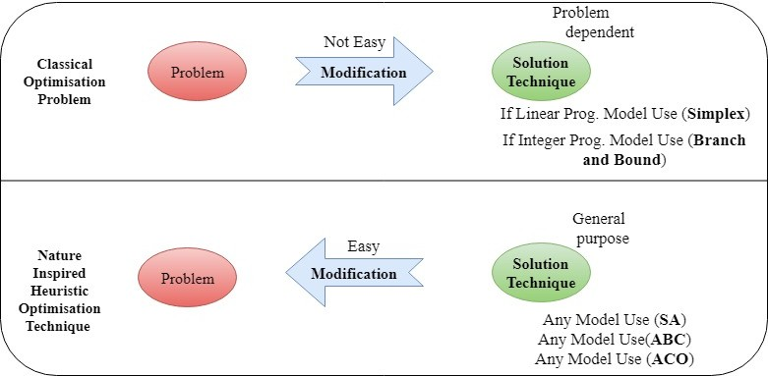

Figure 1: *A pictorial comparison of classical and modern optimisation strategies*

### Ant Colony Optimisation (ACO)

An ACO is based on the metaphor ant seeking food. It is an algorithm developed by Stickland and Dorigo in 1991 for the problem which is based on finding optimal paths in graphs. It is a sign based stigmergy where optimisation problems are visualized as graphs (directed).As we know that ant follows the trails of other ants in process of seeking food, the pheromones re- leased by the former ants helps the latter ants to detect the path trails. Higher the pheromone density larger the number of ants following that path. Ant colony optimisation can be applied to any discrete optimisation problem for which some solution construction mechanism can be con- ceived. For solution first we define a generic problem representation that the ants in ant colony optimisation may exploit to constructed solution afterwards we define the ACO metaheuristic (a method for solving very general classes of problems by trial and error).

### Particle Swarm Optimisation (PSO)

Particle Swarm Optimisation was initially developed by James Kennedy and Russell C. Eber- hart in 1995. After then, it was been improved and redefined by many other researchers. Particle Swarm Optimisation was developed based on the social behaviour of animals that is navigation and forwarding of flock of birds or school of fish in search of food and shelter. PSO depends upon the degree of randomness and freedom. We will study about the proper mathematical ex- pressions and implementation of PSO. This whole optimisation algorithm was developed based on the communication between the particles and learning from each other.

PSO Search Strategy depend upon 3 main factors:

1. Current Position.
2. Personal best location.
3. Team’s best location.

### Artificial Bee Colony (ABC)

The Artificial Bee Colony (ABC) algorithm is a recently introduced swarm intelligence based algorithm inspired by the intelligent food foraging behavior of the honey bees found in nature. ABC algorithm shows more effective when compared to the above optimisation algorithms since it is the latest optimisation technique which is developed by Dervis Karaboga in the year 2005. Since its advent, ABC and its variants have often successfully employed to wide and diverse range of problems, such as numeric optimisation, discrete optimisation, multi-objective optimisation, industrial process control, structural design, design of digital IIR filters, PID con- troller, machine learning and so on. In comparison to other greedy and local search based algorithms, ABC is more resilient against premature convergence and local optima, because the population of candidate solutions can maintain some amount of diversity that is necessary to continue search space explorations avoiding the locally optimal points.

# Background Study

ACO and PSO operation are the best to use in the machine learning as these are the more error less and optimised then the other. Here is the conclusion of some of the reference paper that we review to make our project better and to know more technologies that we can use in our system.

In paper[2] by Saad Ghaleb Yaseen and Nada M.A.AL.-Slamy on Ant Colony Optimisa- tion June 2008 AL-Zaytoonah University of Jordan, they have introduced about the ant colony optimisation algorithm and provides a basic approach of designing meta heuris- tic algorithms for combinatorial optimisation problems. This paper introduces ACO (Ant Colony Optimisation) as a distributed algorithm that is applied to solve Travelling Sales- man Problem (TSP). They have also described how the food seeking behaviour of ants is used as finding optimal path in the Travelling Salesman Problem. This paper also in- cludes how ants adaptively modify the way the problem is represented and perceived by other ants, but they are not adaptive themselves. ACO concepts are used for good prop- agation process, help to find a systematic, effective procedure to find good path for good propagation with respect to some predefined cost and constrains function.

*•*

In paper[3] by James Kennedy’ and Russell Eberhart2 on Particle Swarm optimisation Washington, DC 2012 , 2Purdue School of Engineering and Technology, they have dis- cussed about methods for optimisation of continuous nonlinear functions. They have ba- sically mentioned the origin of particle swarm optimisation. They have also shown a de- tailed study about social behaviour of animals (bird flocking and fish schooling) in search of food. From the nature of animals, they have explained the five basic principles which the particles follow in order to find food- proximity principle, quality principle, diverse response, stability and adaptability. They have also shown the evolution and redefinition of Particle Swarm Optimisation algorithm in which the expression was change from pin- crement,gdecrement to pbest and gbest.

*•*

In paper[4] by Sahil Sobti and Parikshit Singla on Artificial Bee Colony 6 June, 2013 Assistant Professor , DIET , Karnal, they have explained about the performance of ABC algorithm in solving Travelling Salesman Problem. They have also proposed on ABC based algorithm to enumerate rule based system.

*•*

In paper[5] by Ginnu George and Dr.Kumudha Raimond on Artificial Bee Colony 1 March 2013, Computer Science and Engineering Karunya University, they have explained about the performance of variants of ABC in solving TSP. They have also investigated over variants of ABC like I-ABC(Improved) and PS-ABC(Prediction Selection) which are used

*•*

to find optimal path for TSP. The variants of ABC are presented aiming at minimizing the distance of tour. The result of ABC are compared with I-ABC and PS-ABC and it shows that PS-ABC perform well in finding shortest distance within minimum span of time. Also the graphical representation of the comparison of performance of all 3 algorithms are shown.

# Problem Statement

To a given N numbers of stops, identifying the shortest or optimal path from start and back to the original location is a big problem for computation. With increasing number of stops, it is computationally difficult to solve as its complexity increases exponentially.

# Objectives

To perform comparative study of optimisation algorithms for Travelling Salesman Problem in heterogeneous environments.

# Methodology

TSP is used as a benchmark for many optimisation method. Even though the problem is compu- tationally difficult, a large number of heurisitics and exact algorithms are known, so that some instances with tens of thousands of cities can be solved completely and even problems with millions of cities can be approximated within a small fraction of 1percent.[6] In order to do so, these three algorithms **(ACO, PSO, ABC)** are been studied and used.

The overall solving process of the TSP includes:

**Step 1:** Detailed Study about optimisation algorithms.

**Step 2:** Understanding the basic concept and problems in Travelling Salesman Problem.

**Step 3:** Identifying the algorithms which implements TSP.

**Step 4:** Selection of algorithms which can solve TSP.

**Step 5:** Detailed study on selected optimisation algorithms.

**Step 6:** Designing Flowcharts and algorithms of these optimisation algorithms.

**Step 7:** Coding and Testing.

**Step 8:** Implementation of these algorithms in different Environments.

**Step 9:** Comparative Study.

**Step 10:** Report.

To find the best out of these three (ACO, ABC, PSO) algorithms as to solve TSP is our ma- jor concern.Comparing these algorithms in different set of conditions and environments will result in better output. Depending on the results, one will get the best possible algorithm to solve TSP.

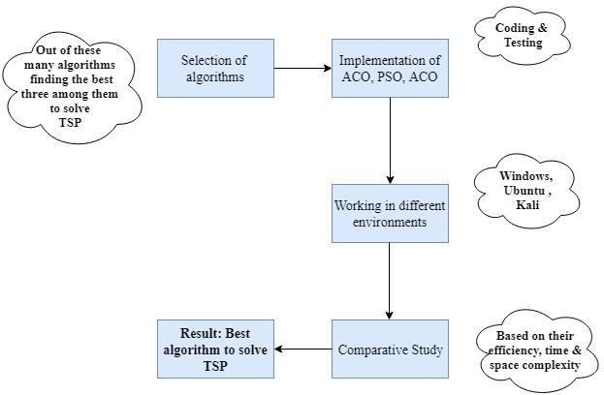

Figure 2: Data Flow Diagram

# System Requirements (Software/Hardware)

* Hardware Interface:
  + 64 bits processor architecture supported by Windows.
  + 64 bits processor architecture supported by Ubuntu.
  + 64 bits processor architecture supported by Kali.
  + Minimum RAM requirement for proper functioning is 500 MB.
* Software Interface:
  + This system is develop in C programming language.
  + GCC Compiler.

# Schedule (PERT Chart)

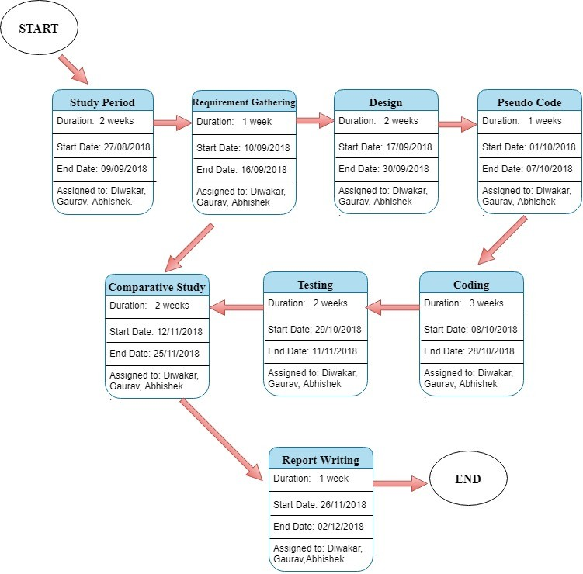

Figure 3: *Pert Chart*

# References

1. M. Alhanjouri, “International Journal of Advanced Research in Optimization Techniques for Solving Travelling Salesman Problem,” no. November, 2017.
2. S. G. Yaseen, “Ant Colony Optimization,” vol. 8, no. 6, pp. 351–357, 2008.
3. J. Kennedy and R. Eberhart, “Particle Swarm Optimization,” pp. 1942–1948, 1995.
4. S. Sobti and P. Singla, “Solving Travelling Salesman Problem Using Artificial Bee Colony Based Approach,” *International Journal of Engineering Research & Technology (IJERT)*, vol. 2, no. 6, pp. 186–189, 2013.
5. G. George, “Solving Travelling Salesman Problem Using Variants of ABC Algorithm,” pp. 97–109, 2013.
6. https://towardsdatascience.com/types-of-optimization-algorithms-\

\used-inneural-networks-and-ways-to-optimize-gradient-95ae5d39529f.